Welcome visitors! We are glad you are here. Please join us immediately after the service downstairs in McMullen Hall for coffee and treats.

Parents, Sunday School for ages 4 to 11 will begin after worship.

While in this sacred space, please silence your cell phones.

Please hold your applause for music until the end of worship.

↑(Indicates a time when you are requested to stand in body or spirit.)


Silent Meditation
October 18, 2026
Twenty-first Sunday after Pentecost
Experiencing God
“...the sacred is in the ordinary, that it is to be found in one’s daily life, in one’s neighbors, friends, and family, in one’s backyard.”—Abraham Maslow

Prelude “Imago Dei”

Welcome to Worship
One: Whoever you are and wherever you are on life’s journey,
ALL: You are welcome here.

Announcements

Ringing of the Bell

Call to Worship
(adapted from Nancy C. Townley, posted on Ministry Matters)
One: God is the God of all life.
All: In God we live and move and have our being.
One: God asks for our faithfulness and our service.
All: We reach out to others with the same kind of love
with which God has touched our lives.
One: Come, let us worship the Lord who is always with us.
Let us praise God who walks daily by our side. Amen.

Prayer for Transformation (adapted from Ministry Matters)
One: God of mercy,
We place our trust in tangible things—
All: Things we can see and touch—
we question whether you are really there.
One: Often we fail to recognize that you are always nearby,
All: Patiently waiting for us to recognize your presence and your glory.
One: Help us when we lose our way,
All: And forgive us when we forget to whom we truly belong.
One: Lover of justice, Open our eyes to see you;
All: Open our ears to hear you;
One: Open our hearts to love you;
All: And open our hands to serve you. Amen.

Moment of Silent Reflection

Words of Assurance

↑Passing of the Peace

Centering Song “We Cannot Own the Sunlit Sky” NCH #563

Prayer for Illumination

First Reading (1 Thessalonians 1:1-10, NRSVUE)

New Testament Reading (Exodus 33:12-23, NRSVUE)

Reflection “Experiencing God” Rev. Kerby Avedovech

Call to Offering (adapted from Jeff Shrowder, posted on The Billabong)

Offering Song “Peace is Flowing Like A River” Traditional, arr. Julie Gaulke

↑Doxology
Praise God from whom all blessings flow
Praise God all creatures here below
Praise God for all that love has done
Creator, Christ, and Spirit One. Amen.

Prayer of Dedication
(adapted from Thom Schuman, posted on Lectionary Liturgies)

Prayers of the Community
(The congregation will respond to each prayerful offering with the following words: “Together with God, we hear your prayers.”)

Today and every Sunday, you are invited to join a prayer circle in the chapel immediately after worship to share your joys and concerns aloud in the supportive company of others.

Pastoral Prayer
(adapted from Rev. Richard J. Fairchild, posted on Kir-Shalom)

Jesus Prayer

↑Words of Mission and Benediction
(adapted from Nathan Nettleton, posted on LaughingBird.net)

Closing Song “Lord, Dismiss Us with Your Blessing” NCH #77

Dismissal to Sunday School
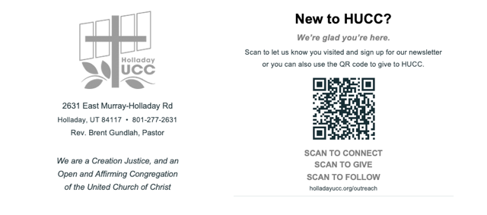
Reader: Nan Sturgeon, Slides: Dale Berreth
Video: Paul Ford, Sound: Connie Nomann
Bell Ringer: Iain McDonald
Music: HUCC Choir

Worship services at HUCC are live streamed on Facebook and YouTube.
Your presence here today is your consent to being part of that broadcast.

Upcoming Events
Glendale Collection every Wednesday at South entrance.
Gatherings Book group meets every Sunday at 9 am in the Chapel.
Caring Ministry Meeting on Zoom – Thursday, October 22nd at 7:00 pm.
HUCC Grief Support group meets October 25th at 11:30 am in McMullen Hall.
New Member Class Sunday, October 25th at 11 am in the Conference Room.
Blessing of the Animals, October 25th at 1 pm in the Courtyard
Prayer Shawl Knitting Group meets Wednesday, November 4th at 3 pm.
Utah Choir Project Trans Visibility Concert on Saturday, November 7th at 5:00 pm.
HUCC Choir rehearses on Wednesdays, Nov.11th & 18th at 6:30 pm in the Choir Room.

