Welcome visitors! We are glad you are here. Please join us immediately after the service downstairs in McMullen Hall for coffee and treats.

Parents: We have free childcare for ages 0-3 in our nursery, next to the gender-neutral bathroom. Sunday School for ages 4-11 will begin after worship.

While in this sacred space, please silence your cell phones.

Please hold your applause for music until the end of worship.

↑(Indicates a time when you are requested to stand in body or spirit.)


Silent Meditation

May 3, 2026
Fifth Sunday of Easter
Preschool Sunday
“The best way to make children good is to make them happy.” — Oscar Wilde

Prelude “Give Thanks” Henry Smith

Welcome to Worship
One: Whoever you are and wherever you are on life’s journey,
ALL: You are welcome here.

Announcements

Ringing of the Bell

Call to Worship (by Christine Longhurst)
One: Come and worship, everyone on earth, everywhere the sun shines,
All: let’s praise God together!
One: For listening when we call, answering our prayers, forgiving our mistakes, and providing what we need,
All: let’s praise God together!
Come and worship, everyone on earth, everywhere the sun shines,
All: let’s praise God together!

Prayer for Transformation (adapted from Carolyn Brown)
God you gave us hands so we might use them help others
But too often we use them to grab what we want.
We ball them up into fists to hit.
We hide them behind our backs
pretending there is nothing we could do to help when we know there is.
So today we turn our hands up to you asking for forgiveness.
Forgive all the bad things we have done.
Wash our hands and make them clean.
Help us to use our hands to do good things.
Teach us to open our hands to share with others.
Give us the power to shake hands with our neighbors.
Show us how to join hands with our neighbors to share your love in the world. Amen.

Moment of Silent Reflection

Words of Grace

↑Passing of the Peace

Centering Song “Lord, Listen to Your Children Praying” K. Medema

Prayer for Illumination

First Reading (Deuteronomy 11:18-21/NRSVUE)

Gospel Reading (Matthew 18:1-5/NRSVUE)

Reflection Genevieve Naylor, Holladay Preschool Board Chair
Call to Offering

Offering Song “For the Beauty of the Earth” NCH #28
Organ – Tammy Taylor, Preschool Director

↑Doxology

Prayer of Dedication

Children’s Chat Sharon Bain, Holladay Preschool

Preschool Performance

Prayers of the Community

Community Prayer (by Marian Wright Edelman)
O God, help us to recover our hope for our children’s sake.
Help us to recover our courage for our children’s sake.
Help us to recover our discipline for our children’s sake.
Help us to recover our ability to work together for our children’s sake.
Help us to recover our values for our children’s sake.
Help us to recover a spirit of sacrifice for our children’s sake.
Help us to recover our faith in You for our children’s sake.

Invitation to the Table

Communion Song “I Come With Joy” Brian Wren, NCH#349

Communion

Jesus Prayer

↑Words of Mission and Benediction

Dismissal to Sunday School

Closing Song “Let Us Talents and Tongues Employ” NCH #347

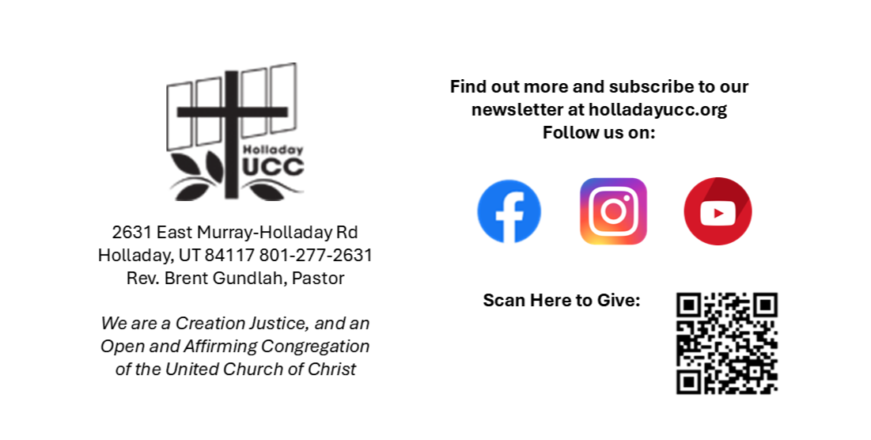
Reader: Jen Smith, Slides: Martha Bale
Video: Jim Bale, Sound: Connie Nomann
Bell Ringer: Iain McDonald
Music: Holy House Band

Worship services at HUCC are live streamed on Facebook and YouTube.
Your presence here today is your consent to being part of that broadcast.

Upcoming Events
ONA Congregational Conversation TODAY in the Sanctuary after worship.
Glendale Collection every Wednesday at South entrance.
Gatherings Book group meets every Sunday at 9 am in the Chapel.
Prayer Shawl Knitting Group meets Wednesday, May 6th at 3 pm.
HUCC Choir rehearses Wednesdays, May 6th and 13th at 6:30 pm in the Choir Room.
Plant Based Eating Group--Friday May 8th 5:30 pm at Jen Smith’s home in Sandy
(Please RSVP via phone/text 801.574.0469 or email jen.smith@mac.com by May 6th.)
HUCC Grief Support group meets May 10th and 24th at 11:30 am in McMullen Hall.

